- \(…)\Setup, Carton Transport
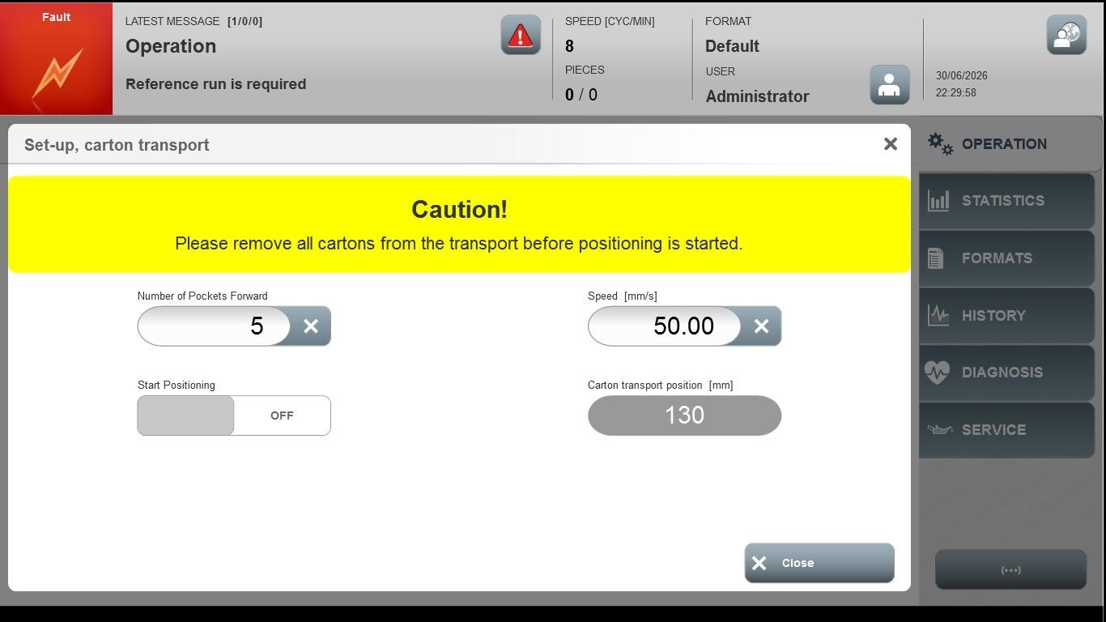
Acceptance criterion | Limits | Pass / Fail: Dev-No. | Date | Initials
Screen matches screenshot | N / A
Number of Pockets Forward | Depending of machime
Speed [mm/s] | Depending of machime

